**Set up lists in SharePoint**

## Project Requests list

The first list is Project Requests, where a project requestor adds a request. The project approver then reviews the request and approves or rejects it.

| **List Column** | **Data Type** | **Notes** |
| --- | --- | --- |
| Title | Single line of text | Default column, used for project name |
| Description | Single line of text |  |
| ProjectType | Single line of text | Values: new hardware, upgraded hardware, new software, upgraded software |
| RequestDate | Date |  |
| Requestor | Single line of text |  |
| EstimatedDays | Number | Enables comparison of requestor estimate to project manager estimate to actual |
| Approved | Single line of text | Values: pending, yes, no |

## Project Details list

The second list is Project Details, which tracks details for all approved projects, like which project manager is assigned.

| **List Column** | **Data Type** | **Notes** |
| --- | --- | --- |
| Title | Single line of text | Default column, used for project name |
| RequestID | Number | Matches the value in the **Project Requests** list **ID** column |
| ApprovedDate | Date |  |
| Status | Single line of text | Values: not started, in progress, completed |
| ProjectedStartDate | Date | When the project manager estimates that the project will start |
| ProjectedEndDate | Date | When the project manager estimates that the project will end |
| ProjectedDays | Number | Working days; would typically be calculated, but isn't in this scenario |
| ActualDays | Number | For completed projects |
| PMAssigned | Single line of text | Project manager |

## Populate Data in lists

Download the sample Excel file from [here](https://download.microsoft.com/download/d/f/6/df6682e2-c625-47f2-9627-b78a86217cd8/project-requests.xlsx).

### Copy data into the list

1. Click or tap **Quick edit**.

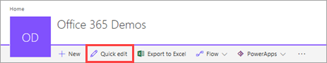

1. Select the cells in the grid.

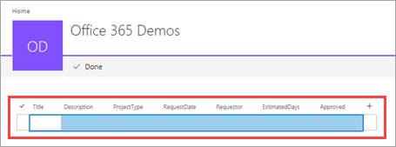

1. Open the [downloaded workbook](https://download.microsoft.com/download/d/f/6/df6682e2-c625-47f2-9627-b78a86217cd8/project-requests.xlsx) and select all the data (not the headings).

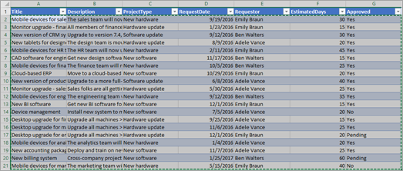

1. Copy the data and paste it into the grid in SharePoint, then click or tap **Done**.

